Report 1 – List of Resources

Indian Credit Market –

Size –
https://www.ceicdata.com/en/indicator/india/domestic-credit
India Domestic Credit reached 3,104.0 USD bn in Aug 2024, compared with a reported figure of 3,084.4 USD bn in the previous month
India Domestic Credit reached 3,035.2 USD bn in March 2024, compared with a reported figure of 2,990.4 USD bn in the previous month.
United States Domestic Credit reached 30,648.3 USD bn in Mar 2024, compared with a reported figure of 30,474.7 USD bn in the previous quarter
China Domestic Credit reached 46,900.8 USD bn in March 2024, compared with a reported figure of 46,279.5 USD bn in the previous month

Growth -
https://www.ceicdata.com/en/indicator/india/domestic-credit-growth
India Domestic Credit increased 11.0 % YoY in Aug 2024, compared with an increase of 10.9 % YoY in the previous month
The data reached an all-time high of 27.1 % in Jul 2009 and a record low of 5.4 % in May 2021.
India Domestic Credit increased 11.4 % YoY in March 2024, compared with an increase of 11.8 % YoY in the previous month
United States Domestic Credit shrunk by 0.3 % YoY in Mar 2024, compared with an increase of 1.5 % YoY in the previous quarter
China Domestic Credit increased 9.6 % YoY in March 2024, compared with an increase of 10.2 % YoY in the previous month

Market Segmentation –
By Type of Borrower -
1. Individual Borrowers (Retail Credit):
- Home Loans: Loans for purchasing residential property.
- Personal Loans: Unsecured loans for various personal needs.
- Auto Loans: Loans for purchasing vehicles.
- Two-Wheeler Loans: Loans for purchasing two-wheelers.
- Consumer Durable Loans: Loans for purchasing consumer durables like electronics, appliances, etc.
- Credit Cards: A revolving credit facility for various purchases.
2. Corporate Borrowers:
- Large Corporates: Large companies that borrow substantial amounts for various purposes like expansion, acquisition, and working capital.
- Small and Medium Enterprises (SMEs): Small and medium-sized businesses that borrow for working capital, expansion, and other needs.
- Micro, Small, and Medium Enterprises (MSMEs): A specific segment of SMEs, often categorized by investment size and annual turnover.
3. Government Borrowers:
- Central Government: Borrows to finance fiscal deficits and development projects.
- State Governments: Borrows to finance state-specific development projects and expenditure.

Key Players –
1. Bank Loans and Overdrafts – Public sector banks, private sector banks, cooperative banks, regional rural banks.
2. Non-Banking Financial Companies (NBFCs)
3. Microfinance Institutions (MFIs)
4. Venture Capital (VC) and Private Equity (PE)
5. Government Schemes and Subsidized Loans
6. Peer-to-Peer (P2P) Lending
7. Corporate Bonds and Debentures

Role of MSME in the Credit Ecosystem
MSME stands for Micro, Small and Medium Enterprises.
Micro enterprises: Investment less than Rs. 1 crore and turnover less than Rs. 5 crore.
Small enterprises: Investment less than Rs. 10 crore and turnover up to Rs. 50 crore.
Medium enterprises: Investment less than Rs. 50 crore and turnover up to Rs. 250 crore
https://msme.gov.in/know-about-msme

Economic Contributions of MSMEs
https://www.un.org/en/observances/micro-small-medium-businesses-day#:~:text=MSMEs%20account%20for%2090%25%20of,and%20groups%20in%20vulnerable%20situations
MSMEs account for 90% of businesses, more than 70% of employment, and 50% of GDP worldwide and therefor are the core of the economy for most societies.
https://msme.gov.in/msme-annual-report-english-2022-23
The Micro, Small & Medium Enterprises (MSME) have been contributing significantly to the expansion of entrepreneurial endeavours through business innovations. The MSME are widening their domain across sectors of the economy, producing diverse range of products and services to meet demands of domestic as well as global markets. The MSME in India are playing a crucial role by providing large employment opportunities at comparatively lower capital cost than large industries as well as through industrialization of rural & backward areas, inter alia, reducing regional imbalances, assuring more equitable distribution of national income and wealth.
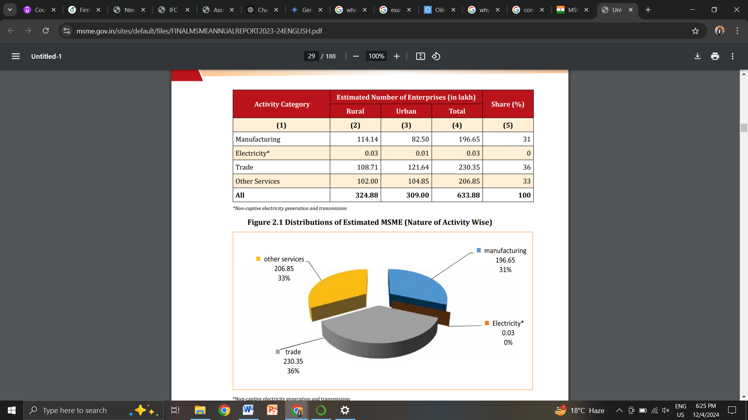
Micro sector with 630.52 lakh estimated enterprises accounts for more than 99% of total estimated number of MSME. Small sector with 3.31 lakh and Medium sector with 0.05 lakh estimated MSME accounted for 0.52% and 0.01% of total estimated MSME, respectively. Out of 633.88 estimated numbers of MSME, 324.88 lakh MSME (51.25%) are in rural area and 309 lakh MSME (48.75%) are in the urban areas.
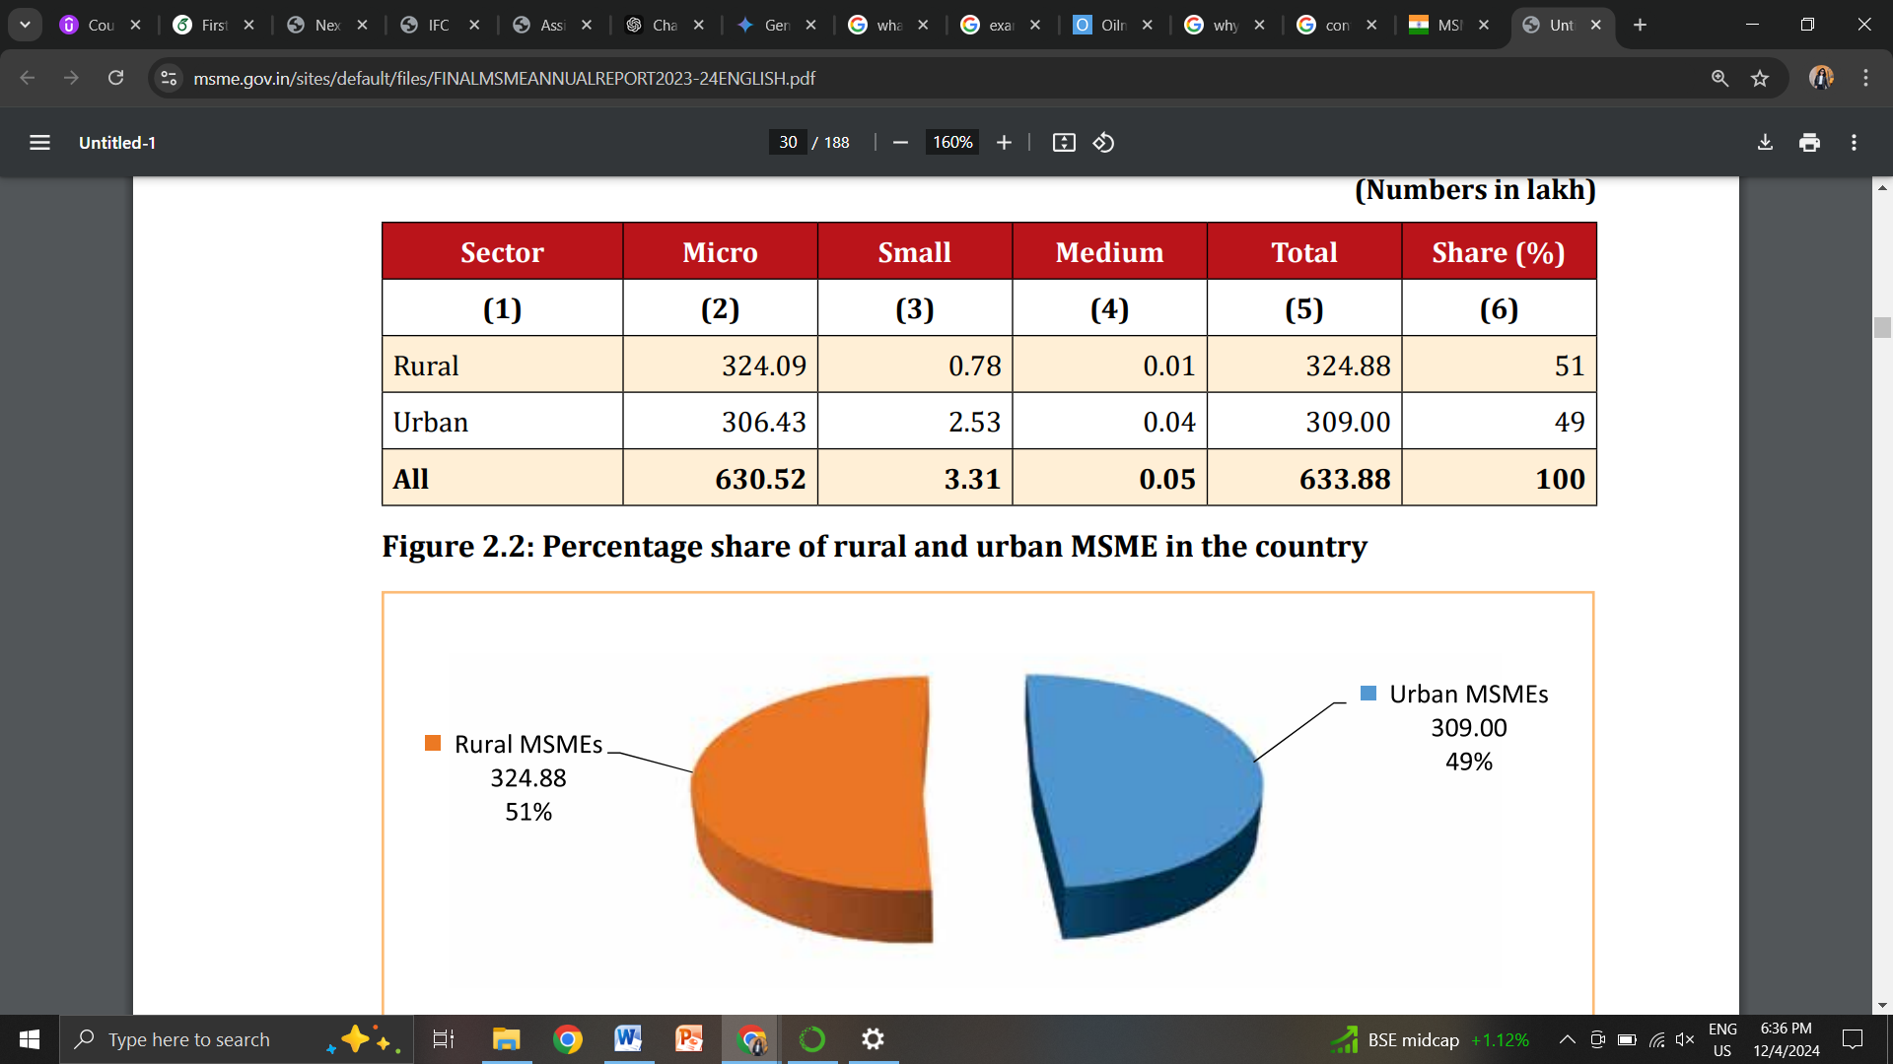

- They create employment –
As per the National Sample Survey (NSS) 73rd round conducted during the period 2015-16, MSME sector created 11.10 crore jobs (360.41 lakh in Manufacturing, 0.07 lakh in Non-Captive Electricity Generation and Transmission, 387.18 lakh in Trade and 362.82 lakh in Other Services) in the rural and the urban areas across the country.
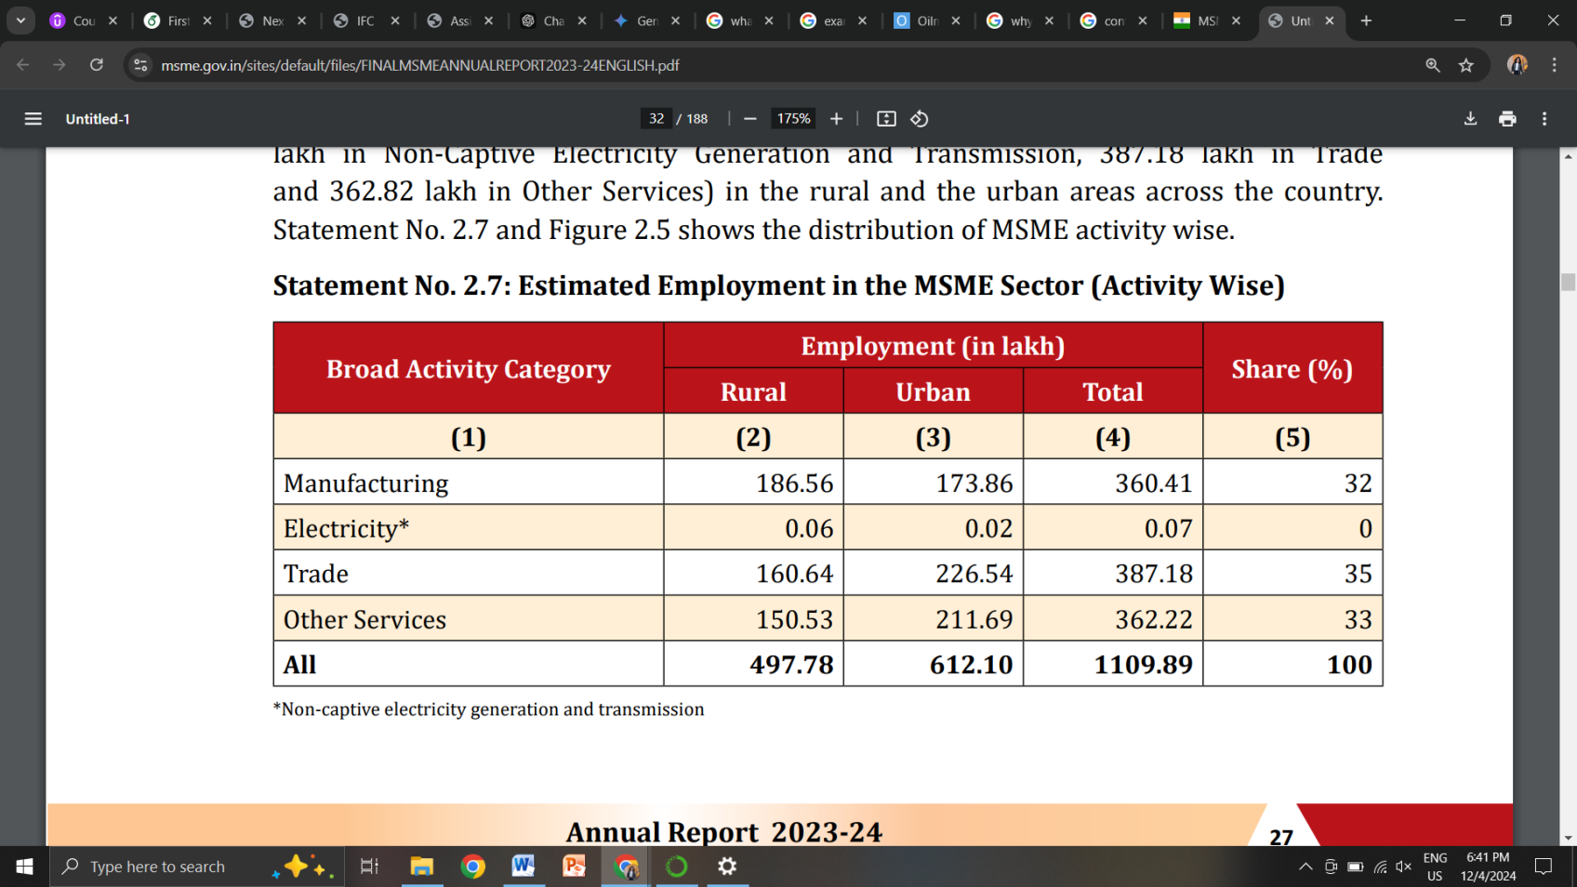
Micro sector with 630.52 lakh estimated enterprises provided employment to 1076.19 lakh persons that in turn accounts for around 97% of total employment in the sector. Small sector with 3.31 lakh and Medium sector with 0.05 lakh estimated MSME provided employment to 31.95 lakh (2.88%) and 1.75 lakh (0.16%)persons of total employment in MSME sector, respectively.
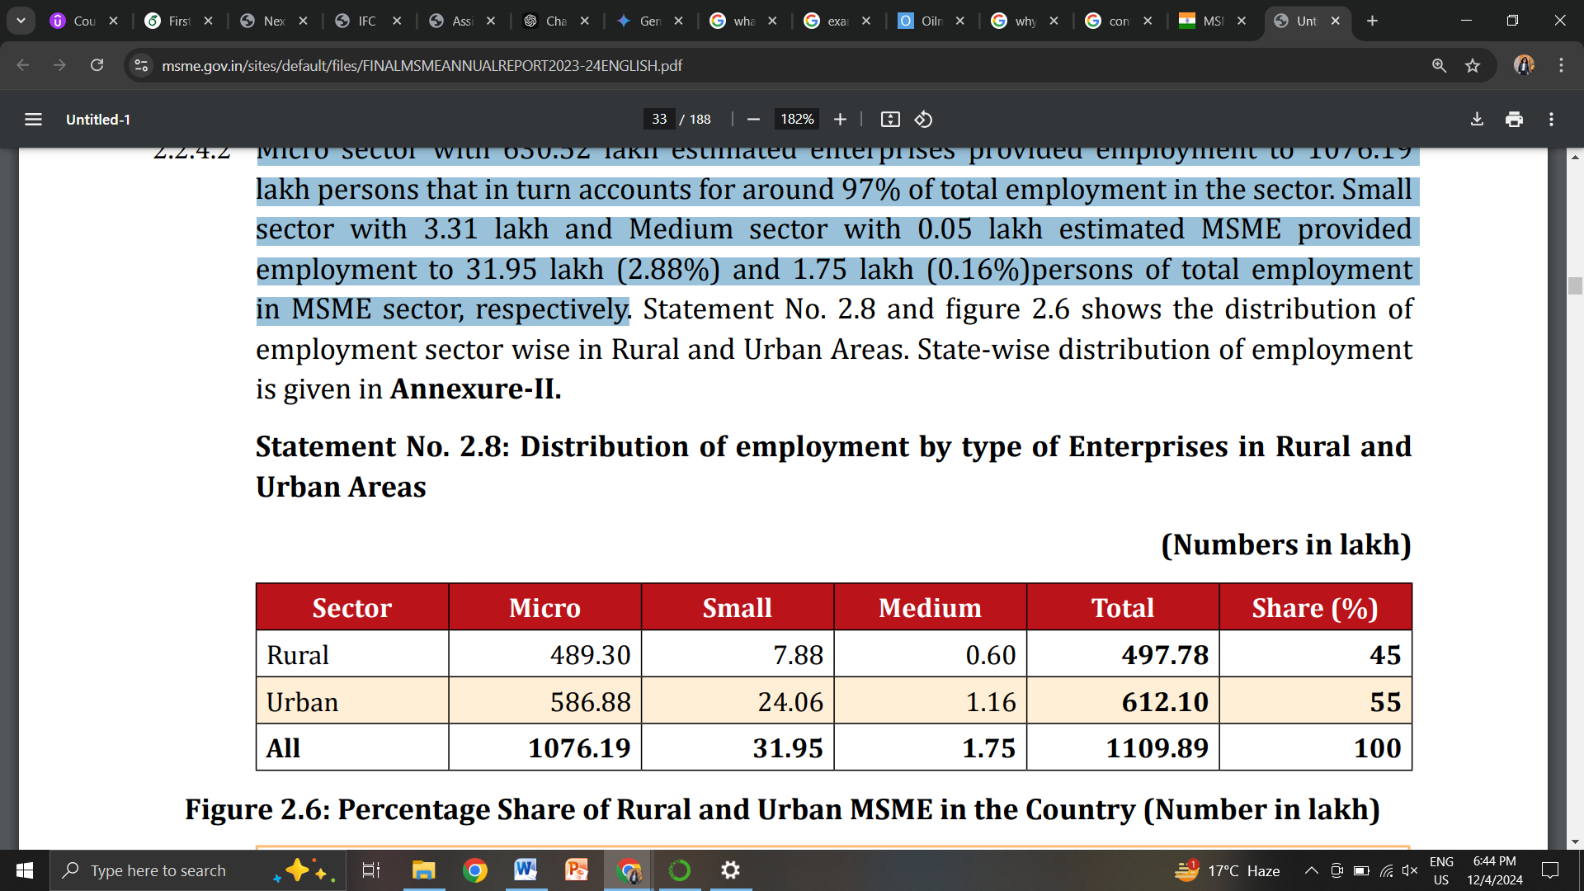
- They contribute to GDP
https://pib.gov.in/PressReleaseIframePage.aspx?PRID=2035073
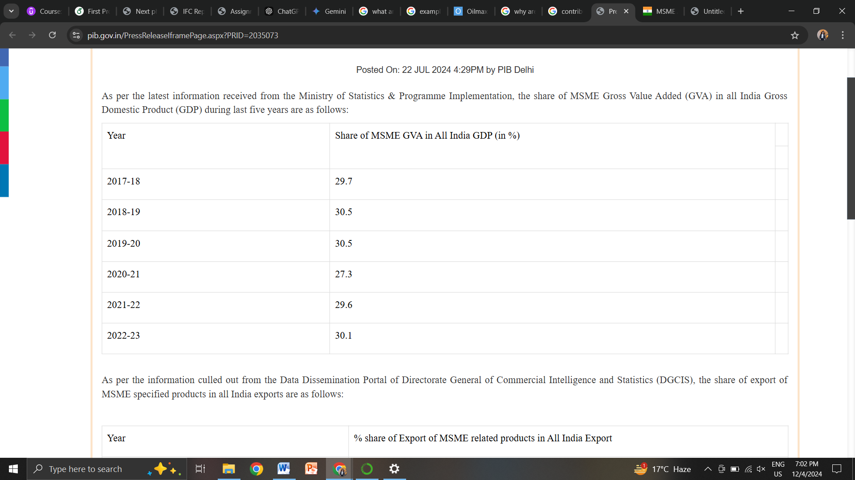
MSMEs contributed 49.75% to India's exports in 2019-20, decreasing to 49.35% in 2020-21 and 45.03% in 2021-22. The share further declined to 43.59% in 2022-23 but recovered to 45.73% in 2023-24, with 45.79% recorded up to May 2024.
- They promote innovation –
https://sustainabledevelopment.un.org/content/documents/26073MSMEs_and_SDGs.pdf
MSMEs promote innovation. While not all MSMEs are innovative, new and small firms are often the driving force behind the innovations that are important for economic growth, since they can work outside of dominant paradigms, exploit technological or commercial opportunities that have been neglected by more established companies or enable the commercialisation of knowledge that would otherwise remain uncommercialised. For instance, MSMEs account for about 20 percent of patents, which is one measure of innovation, in biotechnology-related fields in Europe. MSMEs also contribute to value creation by adopting innovation generated elsewhere, and adapting it to different contexts through incremental changes, and by distributing new or niche products. However, a key challenge for many MSMEs is to identify and connect to appropriate knowledge partners and networks at the local, national and global levels, and develop appropriate skills and management practices for integrating knowledge created by external partners with in-house practices and innovation processes. Examples –
Palsgaard has developed a durable anti-fog coating for industrial food packaging, which keeps food fresh for a longer time, thus helping to reduce food waste. Through its global presence, Palsgaard will market the product worldwide with a particular focus on the major packaging manufacturers in Asia and the United States.
RGS Nordic is developing a digital platform that enables carriers to optimise the use of the many trucks visiting the company’s more than 35 receiving and handling facilities in Scandinavia every day. The solution will significantly reduce the number of empty trucks and, consequently, CO2 and particle emissions. In the long term, the solution will be a best practice example of how sharing of transport data and cooperation between different industry actors can significantly reduce freight on European roads for the good of businesses, the environment and for people.
E.ON is developing a model for replacing fossil fuels in local heat production with eco-friendly and cheaper heat pumps in housing blocks, townhouses and schools. Heat production in many Danish housing associations is still based on fossil fuels like oil and gas. Moreover, a large number of the plants are outdated and not maintained after many years of wear. This results in high energy losses and unnecessary operating costs.

They need credit for the following –
Credit plays a crucial role in business strategies, serving as a key tool to achieve various financial goals and operational objectives. By providing access to funds, credit allows businesses to expand, manage cash flow, make strategic investments, and even weather economic challenges. The strategic use of credit can enhance a company’s competitive position, support growth initiatives, and help in achieving long-term sustainability. Here's an in-depth look at the role of credit in business strategies:

1. Supporting Business Expansion and Growth
- Capital for Expansion: Credit is often used to fund expansion activities, such as opening new locations, entering new markets, or increasing production capacity. Access to credit enables businesses to seize growth opportunities without having to wait for their own capital to accumulate.
- Acquisitions and Mergers: Businesses often use credit (in the form of loans, bonds, or lines of credit) to finance acquisitions of other companies, allowing them to increase market share, diversify products, or gain strategic advantages.
- Product Development: Credit can help fund research and development (R&D) efforts to create new products, services, or technologies. This is especially important for businesses in fast-moving industries where innovation is key to maintaining competitiveness.

2. Managing Cash Flow and Operational Efficiency
- Short-Term Liquidity: Many businesses use credit to manage cash flow gaps, ensuring that they can meet day-to-day operational expenses such as salaries, supplier payments, or inventory purchases. For example, a line of credit or trade credit can provide flexible access to funds as needed.
- Seasonal Business Operations: For businesses with seasonal fluctuations in sales, credit can help bridge the gap during low seasons, ensuring that operations run smoothly throughout the year without interruption.
- Just-in-Time Inventory: By using credit, businesses can finance inventory purchases to take advantage of supply chain efficiencies or capitalize on bulk discounts without tying up a significant portion of their working capital.

3. Enhancing Financial Flexibility
- Leveraging Debt for Growth: Businesses can use credit as a financial lever to increase their return on equity (ROE). For instance, borrowing funds to invest in profitable projects can generate returns higher than the cost of debt, thus enhancing the business's overall profitability.
- Diversifying Funding Sources: A well-rounded credit strategy involves utilizing different types of credit sources—such as bank loans, lines of credit, factoring, or leasing—to diversify funding sources. This reduces dependency on any one source and ensures financial flexibility.
- Cushion Against Market Volatility: Businesses can use credit to build a financial cushion or reserve, which can be useful to manage risks during periods of economic downturns or market volatility.

4. Improving Competitive Position
- Investing in Technology and Innovation: Credit can allow businesses to invest in cutting-edge technologies or automation that improve operational efficiency, reduce costs, or enhance customer experiences, helping them stay competitive.
- Brand Building and Marketing: By using credit to fund advertising and marketing campaigns, businesses can raise brand awareness, attract new customers, and build a loyal customer base, which is crucial in a competitive market.
- Strategic Hiring and Talent Acquisition: Credit can be used to hire skilled employees or invest in training programs to ensure that the business has the right talent to support growth strategies.

6. Supporting Risk Management and Financial Stability
- Hedging against Risks: Credit can help businesses hedge against risks, such as fluctuating commodity prices or currency exchange rates, by providing the necessary funds to implement risk mitigation strategies.
- Emergencies and Contingencies: Businesses often use credit to set aside a contingency fund for unexpected events (e.g., natural disasters, lawsuits, or sudden downturns in business). This ensures that the company can continue operating without disruption, even during challenging times.
- Buffer Against Economic Cycles: During downturns in the economy, businesses with access to credit can continue operating without having to reduce workforce or cut important investments, giving them a strategic advantage when the market recovers.

7. Leveraging Credit for Cost Efficiency
- Financing Capital Expenditures (CapEx): Credit allows businesses to make large capital expenditures (e.g., machinery, technology, property) that will help improve efficiency or generate long-term revenue without impacting immediate cash flow. This is particularly useful in industries with high upfront costs.
- Cost of Capital Optimization: Businesses can take advantage of low-interest rates or favorable lending terms to lower the overall cost of capital, making it more affordable to borrow and invest in growth opportunities.

8. Boosting Customer and Supplier Relationships
- Extended Credit Terms to Customers: By offering trade credit to customers (allowing them to pay later), businesses can build stronger customer relationships and increase sales. This is particularly useful in industries where competition is fierce, and businesses need to incentivize customers with favorable terms.
- Supplier Financing: By utilizing supplier credit or financing options, businesses can negotiate better deals or terms with suppliers, improving profit margins and cash flow management.

Challenges faced by MSMEs –
https://www.crisil.com/en/home/our-analysis/views-and-commentaries/2024/02/for-holistic-growth-ramp-up-msme-farm-support.html
Many MSMEs lack adequate collateral and their financial track record often falls short of credit worthiness standards. Consequently, formal credit penetration in the sector stands at a mere 20%.
https://loksabhadocs.nic.in/lsscommittee/Finance/17_Finance_46.pdf
(Parliamentary standing committee on finance - 2022)
In terms of formalization and access to financial services, the Government data suggest that there are approx. 4.2 crore bank accounts of MSMEs, as in March 2021 and approx. 1.2 crore units are registered under GST. As per data provided by Department of Revenue, out of the estimated 6.34 crore MSMEs, the number of MSME units ever provided credit stood at approx. 2.5 crore. This means that formal credit has ever touched about 39% of the MSMEs. However, as per HDFC and iSPIRT Foundation, out of 6.34 crore MSMEs in the country, only about 1.5 crore (24%) and 0.7 crore (11%) are borrowing from formal Banking system
As per the UK Sinha Expert Committee on MSMEs Report,in India, the total addressable demand for external credit is estimated to be ₹37 trillion (Rs. 37 lakh crore) while the overall supply of finance from formal sources is estimated to be ₹14.5 trillion (Rs. 14.5 lakh crore). Therefore, the overall credit gap in the MSME sector is estimated to be ₹20 – 25 trillion (Rs. 20-25 lakh crore).
(b) According to International Finance Corporation (IFC) of the World Bank Group Report of November 2018 titled ‘Financing India’s MSMEs’, the addressable credit gap for the MSME sector stood at Rs. 25.8 trillion (Rs. 25.8 lakh crore).
(c) As per PriceWaterhouseCooper’s (PwC) report on “Enhancing the MSME financing ecosystem in India” dated November 2019, MSME overall credit demand and gap by 2024 has been projected at Rs. 98 trillion (Rs. 98 lakh crore) and Rs. 37 - 40 trillion (Rs. 37- 40 lakh crore) respectively, which needs to be bridged by formal finance. Credit gap towards working capital and capex has been estimated to be in the ratio of 70:30. Of this, around 70% of MSME credit gap will be attributable to the manufacturing sector.
(d) As per CIBIL report, MSME credit outstanding as on March 31, 2021 was about Rs. 20 lakh crore.
They face a credit gap because –
IOSR Journal of Economics and Finance (IOSR-JEF) e-ISSN: 2321-5933, p-ISSN: 2321-5925.Volume 11, Issue 4 Ser. III (Jul. – Aug. 2020), PP 01-06 www.iosrjournals.org
MSMEs typically are more opaque than large firms because they have less publicly available information. Consequently, it becomes difficult for banks to assess the creditworthiness of MSMEs, which can discourage lending and the lenders can substitute the lack of information with higher requirement of collaterals and high interest rates.
(Abraham Facundo and Schmukler Sergio L., Addressing the SME finance problem, Research and Policy Brief from the World Bank Malaysia Hub, No.9, October, 2017.)
Movable assets (such as machinery, and accounts receivables) account for most of a firm’s assets, particularly for SMEs. However, due to weak legal and regulatory environments, banks are often reluctant to accept these assets as collateral, especially in developing countries.
https://www.bis.org/review/r241126v.htm#:~:text=Many%20MSMEs%20operate%20informally%2C%20making,information%20asymmetry%2C%20particularly%20regarding%20their
Speech by Mr Swaminathan J, Deputy Governor of the Reserve Bank of India, at the CEO Forum of the Federation of Telangana Chambers of Commerce and Industry, Hyderabad, 16 November 2024.
Many MSMEs operate informally, making it challenging for lenders to assess their creditworthiness due to information asymmetry, particularly regarding their financial performance.

How Credit Gap Hampers Job Creation by MSMEs
A significant credit gap can severely hinder the growth and job creation potential of MSMEs. Here's how:

1. Limited Expansion and Growth:
- Restricted Investment: MSMEs often lack the financial resources to invest in new machinery, technology, or expanding their operations. This limits their ability to scale up and create new jobs.
- Working Capital Shortfalls: A lack of working capital can lead to cash flow problems, making it difficult for MSMEs to pay suppliers, employees, and other expenses.

2. Reduced Innovation:
- Limited R&D: Without sufficient funds, MSMEs may struggle to invest in research and development, hindering innovation and the development of new products and services.

3. Missed Contribution to GDP:
MSMEs, which contribute about 30% of India's GDP, cannot reach their full economic potential without sufficient credit, indirectly affecting employment across supply chains and therefore affecting the GDP.

Actionable Solutions –

Govt. Policies –
https://msme.gov.in/sites/default/files/MSME_Schemes_English_0.pdf
Govt. policies should be introduced which focus on
- Providing credit for technology upgradation.
- Provide easy to get loans especially for very small micro businesses
- Provide collateral free loans
- Set up rules to help MSMEs to get payment on time.
- Promote financial literacy
The Indian government has many policies and schemes to support micro, small, and medium enterprises (MSMEs), including:
- Credit Guarantee Fund Scheme
- Micro Finance Program
- Credit Linked Capital Subsidy
- MSME Market Development Assistance
- Coir Vikas Yojana
- Raw Material Assistance
- Marketing Assistance

Technological Solutions –
Alternative credit scoring –
In case of absence of collateral and financial history to assess creditworthiness
- GST filings
- Bank transactions
Automation in loan processing –
- Reduces time and human error
- Digital document verification speeds up processing
Education and awareness through digital channels –
- Educate MSME owners about financial products and credit options
- Spread awareness about Ministry of MSME portals that provide resources and information
Blockchain Technology –
- Enhances security and transparency of financial transactions, reducing the risk of fraud and default.
- Smart contracts help to save time and money and improve accuracy by automating the entire process.

Fintech Solutions –
Digital lending platforms –
- No transport cost
- Simplified application process
- Example lendingkart, capital float
Embedded finance –
- Integrate finance services with non-financial platforms like e-commerce sites.
- Example amazon lending, flipkart seller hub.
Peer to Peer Lending –
- Helps connect borrowers directly to lenders bypassing traditional banks
- Can help offer customized loans
- Example Faircent, Liquiloans.

